Team 5

[SP16.CPSC.2100.21094](https://utclearn.utc.edu/webapps/blackboard/execute/launcher?type=Course&id=_4311_1&url=)

Group Project 1

Part 1

Patel Alaykumar

Phillips Christian

Clark Stephen

Stovall Jose

Hullander Steven

First of all, we have discussed the problem and then as a leader, I let everyone to decide how they all wanted to break the problem apart. We all agreed to volunteer for which part of the problem we wanted to complete. Jose decided to do parts 1 and 2, Stephen decided to do parts 3 and 4, I decided to do part 5 and 8, Christian decided to do part 6, and Steven decided to do part 7. After dividing problem in group, we agreed to get in touch and provide updates of our work via. Group text message.

After everyone was on track, we met and reviewed each other’s work. For some part, we got confused, but everyone’s opinion and thought helped to get solution to the questions. After review the final stage was to finalize and to put everyone’s work in one single document.

College of Computer Engineering

The University of Tennessee at Chattanooga

February, 2016

**TABLE CONTENTS**

1. Problem Description………………………………………………………………………………..(Page 3)
2. Activity Diagram………………………………………………………………………………….....(Page 4)
3. Use-Case Diagram…………….……………………………………………………………….….…(Page 5)
4. Class Diagram……………………..……………………………………………………………….....(Page 6)
5. Object Diagram……………………………………………….………………………..…............(Page 7)
6. CRC cards listing.……………………………………………………………...…………............(Page 8)
7. Sequence Diagrams……………………………..………………………………………….…(Page 9-12)
8. State Machine Diagrams ……………………………….………………………..……….(Page 13-15)

**Online University Registration (OUR) System**

Universities nowadays have their own online registration system to facilitate the course registration process where each student can use it to register for his/her courses before the semester begins. The system also enables the staff of each academic department to examine the course offered by their department, add and remove courses, and change the information about them (e.g., the maximum number of students permitted, course description, unique course number, course name, section number, time, etc.). It should permit students to examine currently available courses, add and drop courses to and from their schedules, and examine the courses for which they are enrolled. The system will allow the student to register for a single course only once and will allow them to print their schedule for the semester. Department staff should be able to print a variety of reports about the courses and the students they are enrolled in them. The system should ensure that any student will take no less than three courses and no more that five courses for each semester. Students who have any unpaid fees are not permitted to register (assume that a fees data store is maintained by the university’s financial office, which the registration system accesses but does not change). On the other hand, the system will allow the instructors to print reports about the courses they teach and the list of students enrolled in each course. Each user will maintain a user name and password that will allow him/her to access the system.

For the first part of CPSC 2100 project, you are required to create a set of design diagrams for the Online University Registration (OUR) System including the following:

1. **Create an Activity Diagram for the OUR system.**

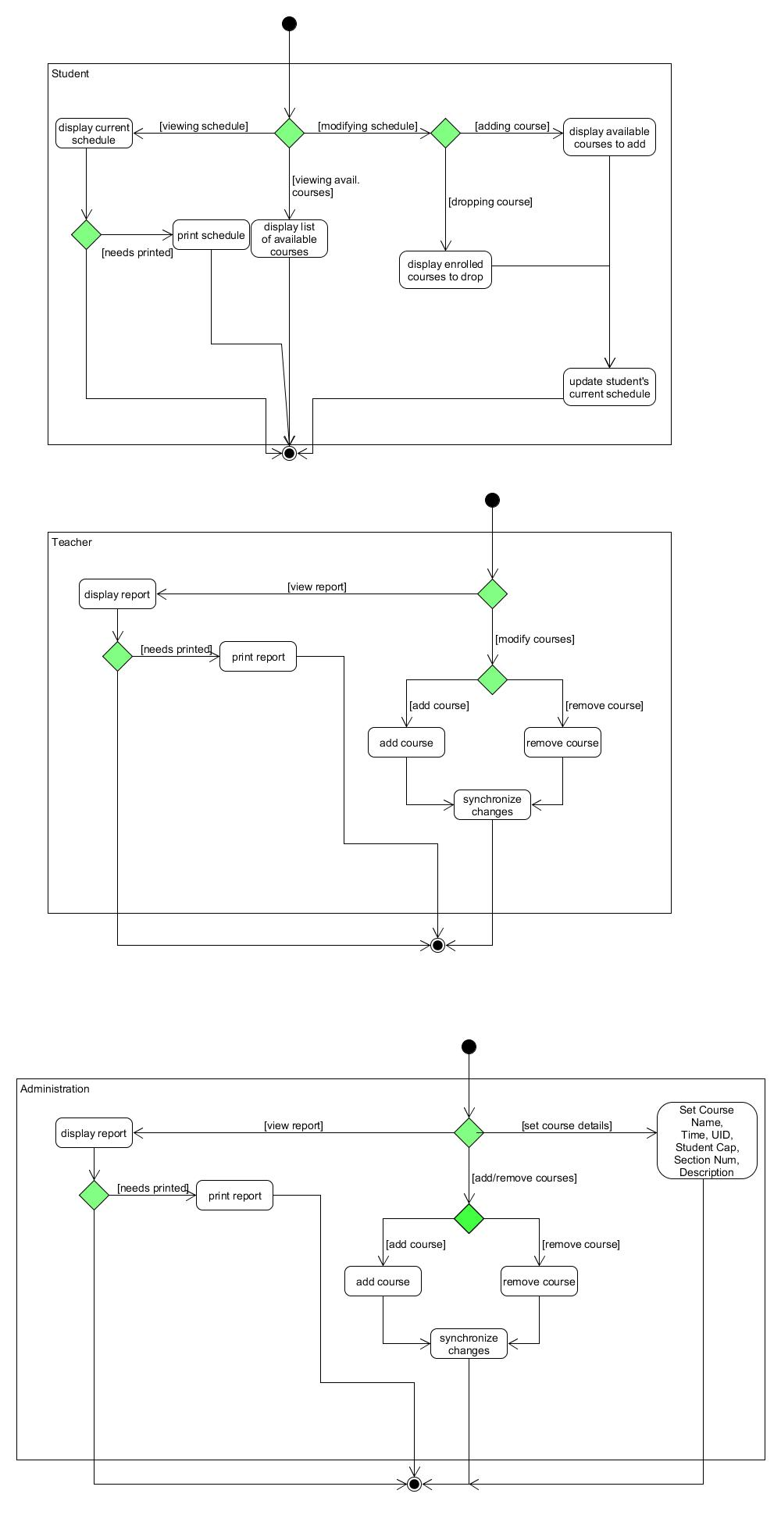

1. **Create a use-case diagram for the OUR system.**

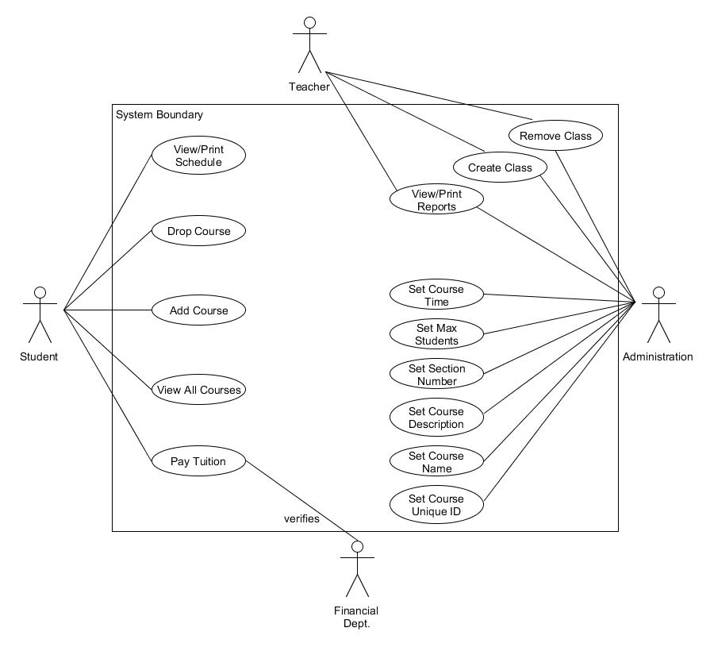

1. **Create a Class Diagram for the OUR system.**

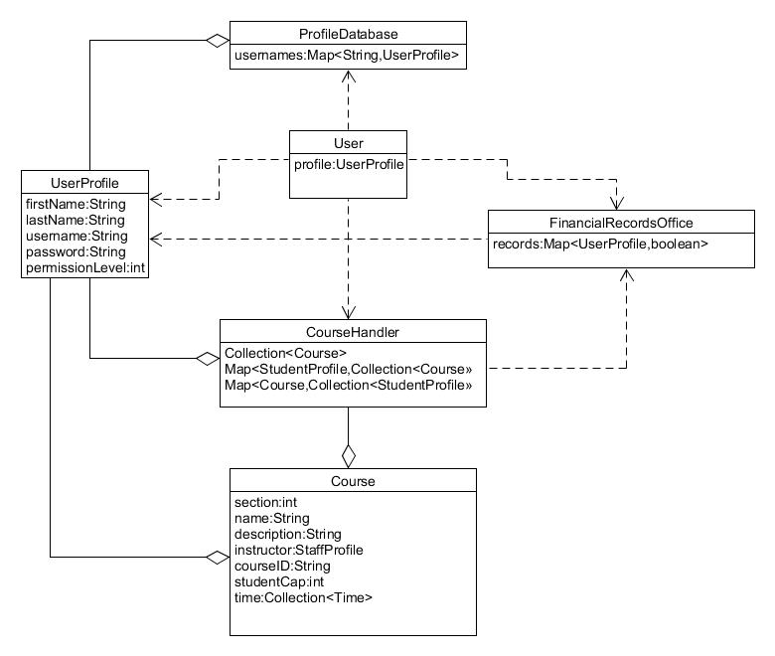

1. **Create Object Diagram example from your Class Diagram created in 3.**

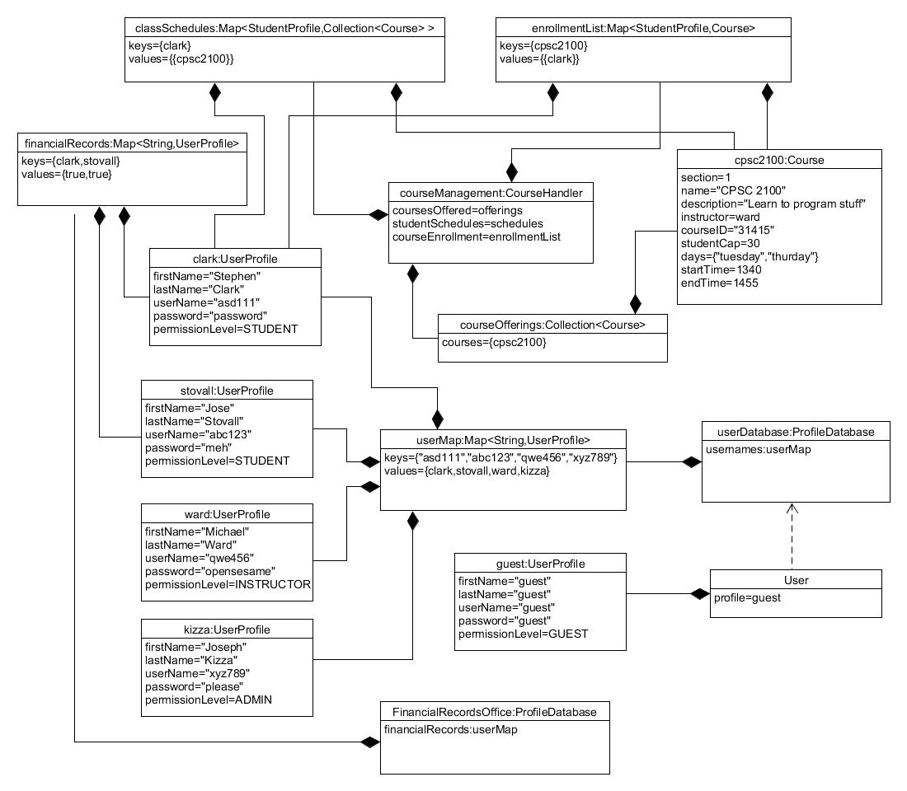

1. **Create a set of CRC cards listing all the attributes and the collaboration for all the potential classes of the OUR system.**

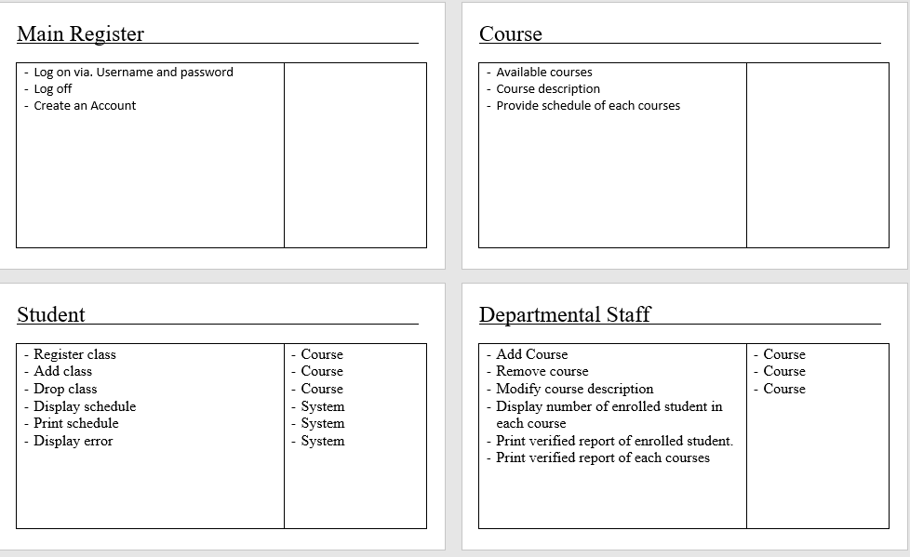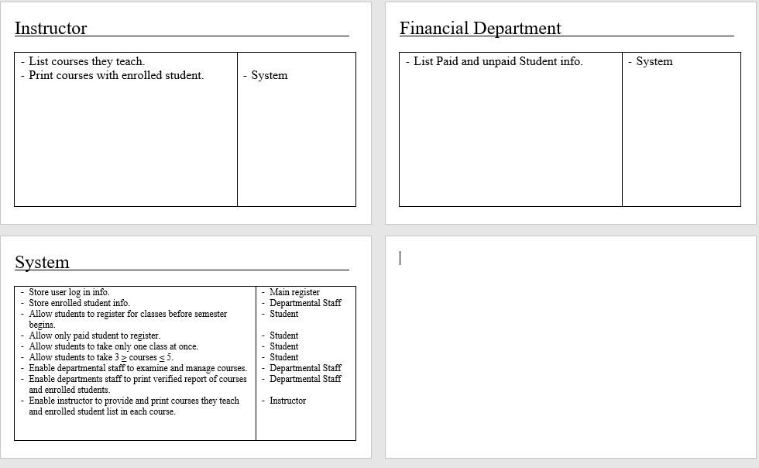

1. **Create a set of sequence diagrams for four different scenarios that could occur in the OUR system. For each sequence diagram you need to provide a small paragraph describing the sequence in your scenario presented in your diagram.**

**Scenario 1:**

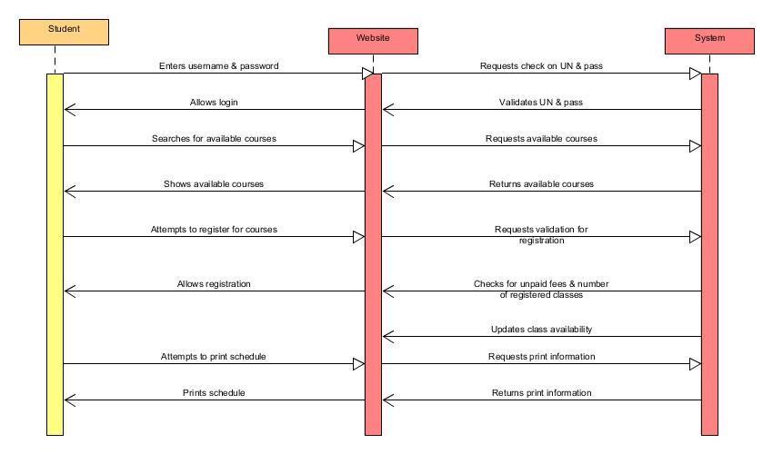

A student searches for classes that he/she wants to register for during the next semester. After finding the desired classes, the student attempts to register for the classes he/she selected, and then the system checks to see if the classes have any availability. If the classes are available then the system allows registration as long as the number of registered classes falls within the allotted range of 3-5, and after checking to see if the student has any unpaid fees. After registration is confirmed the system updates the class availability and allows the user to print a schedule.

**Scenario 2:**

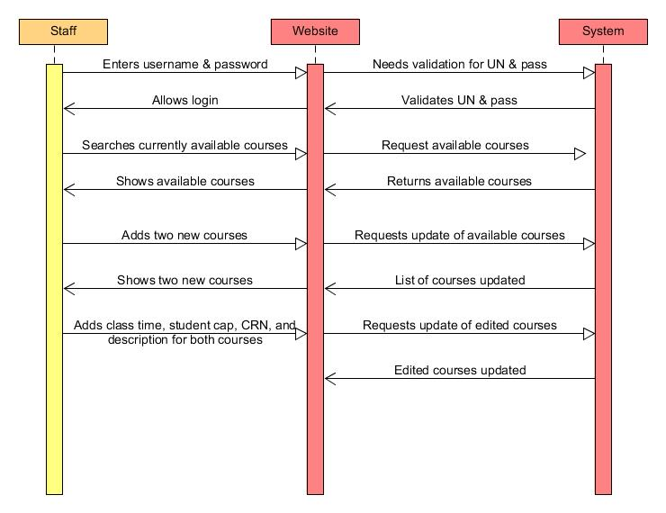

A department staff member plans to add two new classes to the system to have more room for students to register. The staff member first looks at the currently available courses to see what current times the other classes are being held. Afterwards, the staff member adds two new classes and the system updates the running list of classes with the two new additions. The staff member then adds a time, description, course number, and maximum class size to both of the classes. Lastly, the staff member saves the changes and the system updates the two classes with the new information, allowing the new courses to be seen by students.

**Scenario 3:**

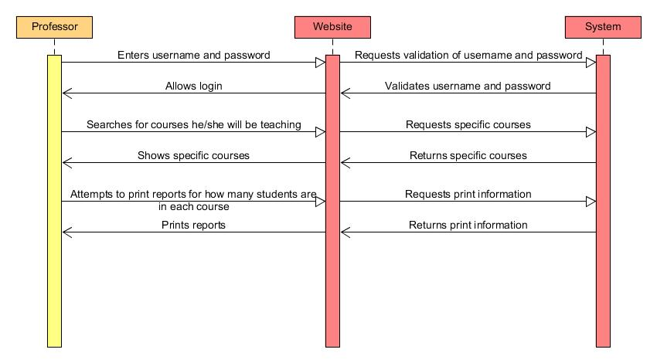

A professor wants to know how many students will be in all of the classes that he/she is teaching. After logging into the system, the professor searches the courses that he/she will be teaching and looks to see how many students each class will have. After seeing this information the professor then prints a report about each classes, listing the class size, students attending, etc.

**Scenario 4:**

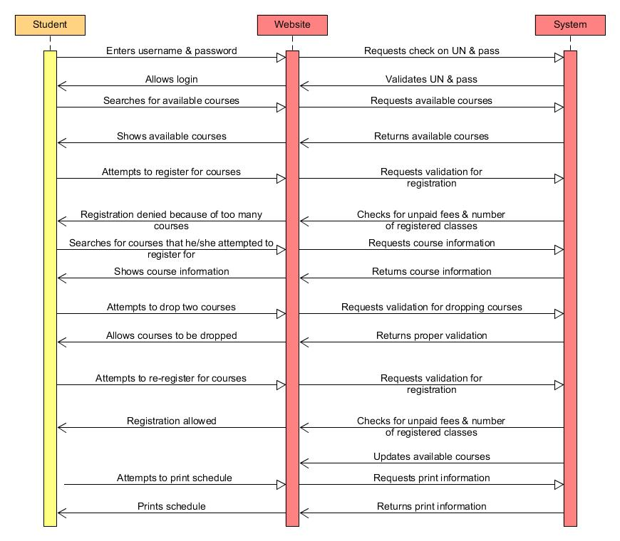

A student searches for classes that he/she wants to register for during the next semester. After finding the desired classes, the student attempts to register for the classes he/she selected, and then the system checks to see if the classes have any availability. After the system checks for class availability, it runs a check to see if the student has any unpaid fees and if the amount of classes the student is trying to register for fall within the allotted range of 3-5 classes. After doing the checks, the system sees that the student is trying to register for 7 classes and denies his/her registration. The student then drops two of the classes that he/she is trying to register for and tries to re-register for the classes. After the system does another check of unpaid fees and amount of classes, it allows registration and updates the availability of the classes. The user then prints his/her schedule.

1. **Create a set of state machine diagrams for the classes in the OUR system.**

